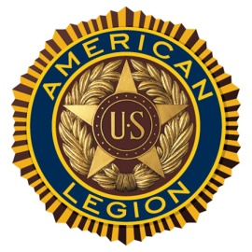
James S. Moore
American Legion Post 167
P.O. Box 104 Downsville NY, 13755

Hall Rental Agreement

Use of legion hall fees:
*Deposit for reserving the hall is due at the time of this agreement:
__X___ Refundable Deposit $25
_____ Use of Stove or Ovens add additional $10
Please check the options you need
_____ 2 hours or less
_____ 2 hours to 4 hours
_____ 4 hours or more

Date Requested:____________________ Time:_______-_______ Total Due $____________
I agree to make a reasonable donation for the use of the legion hall after my event. I will clean up after the use of the hall to include wiping down tables, sweeping the floor (including bathrooms & kitchen), emptying the trash cans and taking trash with me. If I fail to clean up and take my trash with me, then I will forfeit my $25 deposit.
I also agree that I WILL NOT SERVE ALCOHOL TO ANY MINORS. If said action is seen, my party will be asked to leave the legion hall at once.

Print Name:_______________________________________ Phone #:_______________________
Renter’s Signature:_________________________________ Date:__________________________
Legion Member Signature:___________________________ Amount Received: $______________

